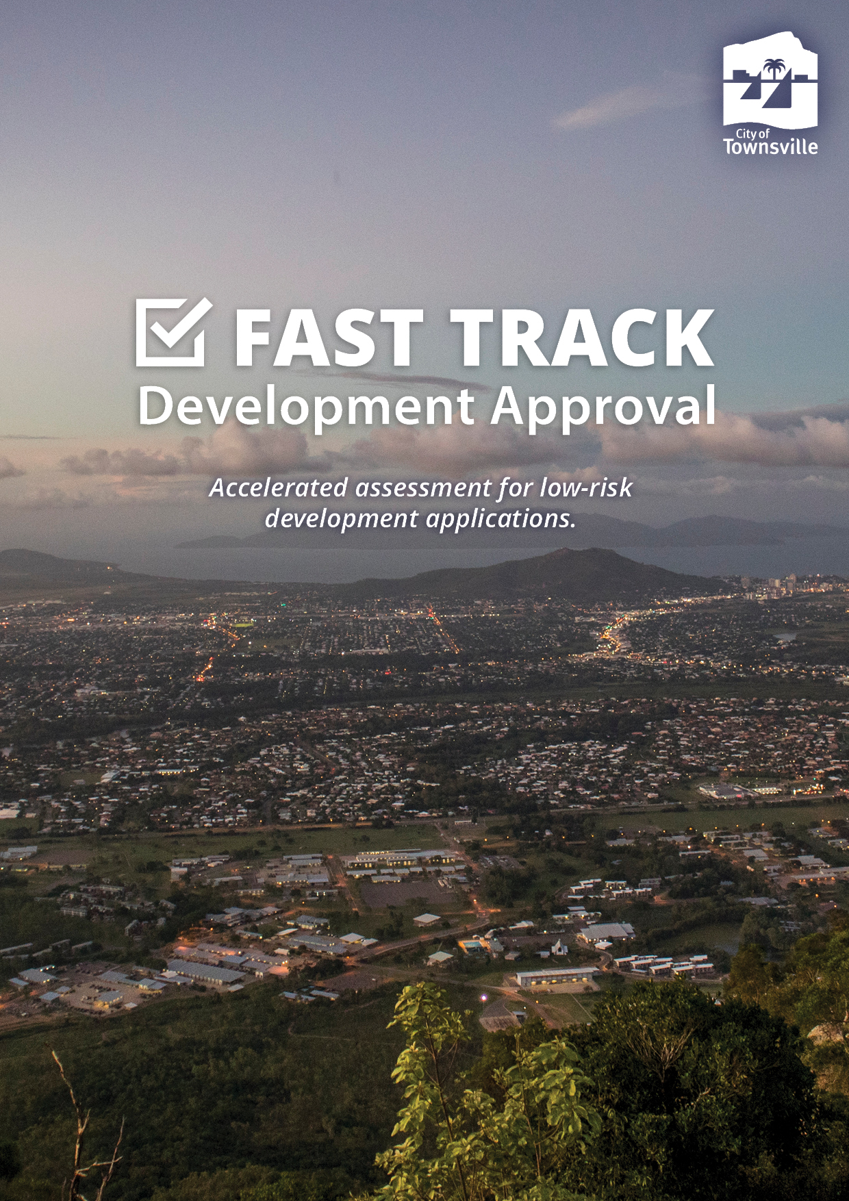

  - Report Template
  - Prepared by: Insert Consultancy Name Here
Application Summary
Application Type | Development Permit - Reconfiguring a Lot / Operational Work / Building Work / Material Change of Use
Application Description | e.g. Lot Creation – 1 into 2 Lots
Property Address | Street Address
Legal Description | Lot on Plan
Assessment benchmarks | Planning Act 2016  Planning Regulation 2017  State Planning Policy  North Queensland Regional Plan 2020  Any Variation Approval (Preliminary Approval)  Townsville City Plan  • Insert Zone Code  • Insert Overlay Codes  • Healthy waters code  • Landscape code  • Transport impact, access and parking code  • Works code
Level of assessment | Code Assessable
Date Lodged | Date Lodged
Applicant | Applicant
Referral Agencies | Nil  OR  North Queensland State Assessment and Referral Agency
Property Notations | Please list Conditions with Property Notations

- Executive Summary
The application seeks a Development Permit for Material Change of Use / Reconfiguring a Lot / Building Work / Operational Works for an Insert Description located on land situated at Address. The application is Code Assessable against the Townsville City Plan, in particular the insert zone code, among other relevant assessment benchmarks.
Following assessment against the applicable codes it is recommended that the application be approved in accordance with the Townsville City Plan, subject to reasonable and relevant conditions.

- Background / History (If Applicable)

- Site / Locality

Site And Locality Description
Land Area:
Existing Use of Land:
Road Frontage:
Surrounding Land Uses:

The property is located in the insert zone of the Townsville City Plan. The site has an area of Xm² and is currently vacant OR contains _____.

Figure 1: Aerial Image

- Proposal
The subject application seeks approval for Insert Description.

Figure 2: Site Plan

- Assessment
The following Assessment Benchmarks from the Planning Regulation 2017 are applicable to this application:
- Planning Act 2016
- Planning Regulation 2017
- State Planning Policy
- North Queensland Regional Plan 2020
- Any Variation Approval
- Townsville City Plan

  - The Planning Act 2016 and The Planning Regulation 2017
The Planning Act 2016 provides for an efficient and effective system of land use planning and development assessment to facilitate ecological sustainability. The proposal has been assessed in accordance with all relevant sections of the Act and the provisions of the Planning Regulations.

  - State Planning Policy
The State Planning Policy (SPP) is a key component of Queensland’s land use planning system, which enables development, protects our natural environment and allows communities to grow and prosper.
The SPP provides a comprehensive set of principles which underpin Queensland’s planning system to guide local government and the state government in land use planning and development assessment.
The Townsville City Plan is appropriately integrated with the SPP July 2014 version and assessment has been conducted against the SPP July 2017 version, where the proposed development is considered to be consistent with all relevant State interests.

  - North Queensland Regional Plan 2020
The North Queensland Regional Plan (NQRP), which came into effect on 6 March 2020, is a 25-year strategic, statutory planning document for the local government areas of Burdekin, Charters Towers, Hinchinbrook, Palm Island and Townsville. It has been developed through a close collaboration between local councils, Traditional Owners, state agencies, industry and the community. The Plan interprets and applies the State Planning Policy in the context of North Queensland to provide a planning and decision-making framework that responds to the region’s particular social, economic and environmental issues.

The application has been assessed against the NQRP and found to be consistent with its goals, outcomes and policies.

  - Townsville City Plan
The applicable planning scheme for the application is the Townsville City Plan, version Insert. The application has been assessed against the following section/s of the planning scheme:

- Insert zone code
- Healthy waters code
- Landscape code
- Reconfiguring a lot code(If Applicable
- Transport impact, access and parking code
- Works code
- Insert overlay code
- Insert overlay code

    - Planning Scheme Codes
The application has been assessed against each of the applicable codes and found to be consistent with, or can be conditioned to comply with, each. The pertinent issues arising out of assessment against the codes are discussed below:

OR

The application has been found to conflict with one or more elements of the applicable codes of the planning scheme and cannot be conditioned to comply. The pertinent issues arising out of the assessment are discussed below.

      - Insert zone code
Insert purpose of the zone code.

Insert PO (Performance Outcomes) and AO (Acceptable Outcomes) and discuss assessment.

The proposal has been assessed against and considered consistent with the ____ zone code.

      - Healthy waters code
The purpose of the Healthy waters code is to ensure development manages stormwater and wastewater as part of the integrated total water cycle, and in ways that help protect the environmental values specified in the Environmental Protection (Water) Policy 2009.

Insert PO and AO and discuss assessment.

The proposal has been assessed against and considered consistent with the Healthy waters code.

      - Landscape code
The purpose of the Landscape code is to ensure landscaping in both the private and public domains is designed and constructed to a high standard, provides a strong contribution to the city image, is responsive to the local character, site and climatic conditions and remains fit for purpose over the long-term. It ensures high quality landscaping is achieved onsite, and on the street to enhance the character of the city whilst integrating with the natural and built form elements of the site and the locality.
Insert PO and AO and discuss assessment.

The proposal has been assessed against and considered consistent with the Landscape code.

      - Reconfiguring a lot code
The purpose of the Reconfiguring a lot code is to facilitate the creation of attractive, accessible and functional neighbourhoods and districts, that are well-integrated, compact and sustainable whilst protecting the productive capacity, landscape character and ecological and physical functions of Townsville’s diverse natural resources. New allotments must be designed, and of a size suited to the intended use of the land having regard to the ability to accommodate buildings, vehicle access, parking and onsite service, and create walkable residential neighbourhoods that are accessible to community facilities and employment opportunities.

Insert PO and AO and discuss assessment

The proposal has been assessed against and considered consistent with the Reconfiguring a lot code.

      - Transport impact, access and parking code
The purpose of the Transport impact, access and parking code is to ensure appropriate provision for transport and end of trip facilities and to facilitate, as far as practicable, an environmentally sustainable transport network. It ensures the function, safety and efficiency of the transport network is optimised and that pedestrians and cyclists are provided with a high level of accessibility.

PO17 – Provision is made for on-site vehicle parking to: (a) meet the demand likely to be generated by the development; (b) avoid on-street parking that would adversely impact on the safety or capacity of the road network or unduly impact on local amenity.

AO17 – Parking is provided in accordance with the standards identified in Parking rates planning scheme policy no. SC6.10.

The proposal has been assessed against and considered consistent with the Transport, impact, access and parking code.

      - Works code
The purpose of the code is to ensure all works associated with the development achieve an appropriate level of service which maintains or enhances community health, safety and amenity and are undertaken in an environmentally sensitive manner.

Insert PO and AO and discuss assessment.
The proposal has been assessed against and considered consistent with the Works code.

      - Airport environs overlay code
The purpose of the Airport environs overlay code is to ensure that development avoids adversely affecting the safe and efficient operations of the Townsville Airport, RAAF base and other aviation facilities. Development must not increase the risk to public safety and no worsening of people affected by significant aircraft noise to be avoided.

Insert PO and AO and discuss assessment

The proposal has been assessed against and considered consistent with the Airport environs overlay code.

      - Flood hazard overlay code
The purpose of the Flood hazard overlay code is to manage development outcomes in flood hazard areas so that risk to life, property, community, economic activity and the environment during future flood events is minimised, and to ensure that development does not increase the potential for flood damage on-site or to other property.

Insert PO and AO and discuss assessment.

The proposal has been assessed against and considered consistent with the Flood hazard overlay code.

      - Insert overlay code
Insert purpose of the overlay code

Insert PO and AO and discuss accordingly

The proposal has been assessed against and considered consistent with the ___ overlay code.

- External Referrals
The proposed development did not trigger external referral in accordance with the provisions of the Planning Regulation 2017.

OR

The proposed development was required to be referred to the North Queensland State Assessment and Referral Agency as a Referral Agency as the development is triggered in Schedule Insert, Part Insert, Division Insert, Table Insert, Item Insert as the development is Insert. The Department provided a response and referral conditions for the proposed development on Insert and have been included with Council's conditions.

- Local Government Infrastructure Plan (LGIP)

The Townsville City Plan includes a Local Government Infrastructure Plan (LGIP) that has been prepared under the Minister’s rules. The LGIP includes Townsville’s priority infrastructure area (PIA). The PIA identifies where the serviced, or intended areas to serviced with development infrastructure networks are located and the approved use for those areas, being residential (other than rural residential), industrial, retail, commercial, community or government purpose.

The application has been reviewed against the provisions of the LGIP and it is confirmed that the use does not affect, alter or trigger any new trunk infrastructure works.
- Infrastructure Charges (if applicable)

The development is subject to the Infrastructure Charges Resolution 2023/2024.

- Conclusion
The proposal is for a Development Permit for Material Change of Use / Reconfiguring a Lot / Building Work / Operational Works for Insert Description generally comply with the provisions of the Townsville City Plan. While the proposal does not meet _____ as prescribed by the Townsville City Plan, it is considered that the provision of ______ can be reasonably conditioned to ensure the development achieves compliance with the relevant Assessment Benchmarks.
- Recommendation
That the application seeking a Development Permit for Material Change of Use / Reconfiguring a Lot / Building Work / Operational Works for Insert Description for Insert Description located at Insert Address situated on be approved subject to reasonable and relevant conditions.

- Statement Of Reasons
Subject to the imposition of the development conditions contained within the Decision Notice, the development is able to comply with the following applicable Assessment Benchmarks against which the application was required to be assessed. Detailed reasons for approval addressing particular Assessment Benchmarks are provided below, where relevant.

Applicable Assessment Benchmarks:
Planning Act 2016
Planning Regulation 2017
State Planning Policy
North Queensland Regional Plan 2020
Any Variation Approval (Preliminary Approval)
Townsville City Plan
• Insert Zone Code
• Insert Overlay Codes
• Healthy waters code
• Landscape code
• Transport impact, access and parking code
• Works code

Reason for approval
The application was approved despite non-compliance with the elements of certain Assessment Benchmarks listed below for the following reasons:

Assessment benchmark (Insert code name)
Insert section of the code (PO benchmark) where application is considered to not comply.

Reason
Insert reason why the application was approved despite the development not complying the benchmark.

Assessment benchmark (Insert code name)
Insert section of the code (PO benchmark) where application is considered to not comply.

Reason
Insert reason why the application was approved despite the development not complying the benchmark.

Assessment benchmark (Insert code name)
Insert section of the code (PO benchmark) where application is considered to not comply.

Reason
Insert reason why the application was approved despite the development not complying the benchmark.

Accredited Consultancy:
Accreditation number:
Professional preparing report:
Consultancy signature:
Date:

SCHEDULE OF CONDITIONS

MATERIAL CHANGE OF USE/RECONFIGURING A LOT/ BUILDING WORK/ OPERATIONAL WORKS
INSERT DESCRIPTON

