Risk Matrix
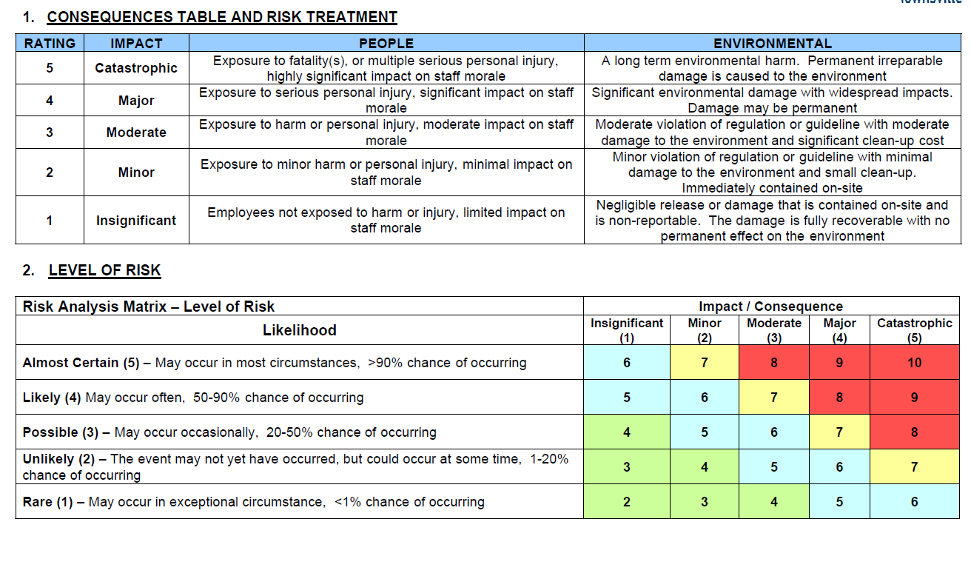
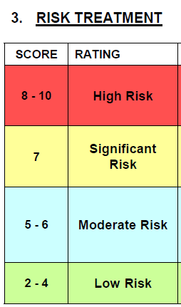

Location: |  |  |  |  |  | Business Owner Name:
Title: | Risk Assessment for Operation of
Prepared by: |  |  |  | Date:
Approved by: |  |  |  | Date:
Issue | Existing Controls | Impact Analysis  Likelihood (L) & Consequence (C) |  | Risk Level | Treatment Option/Additional Controls  (including responsibility) |  |  |  | Level of Residual Risk
 |  | L | C |  | Control Measures |  |  | Monitoring
1. Conflicting Users
2. Public Complaint’s
3. Ensuring Safe Operation
4. Incident/accident reporting
5. Dealing with crowded conditions
6. Needle find procedure
7. Marine Stingers & Predators
8. Heat Stroke
9. Sunburn
10. Working with Children
11. Injury on site
12. Intoxicated Persons
13. Emergency Evacuation
14. Storms
15. Generators/Electrical Equipment
16. Damaged/Broken Equipment
17. Staff Training
18. Management of risks association with Covid 19

CONSENSUS FORM
S FORM
The section verifies by signature that participation of all personnel listed as contributing upon completion of the document/procedure and allows for documented evidence should consensus not be achieved. The concerns of dissenting persons shall be detailed in the section below.

Document Name: Risk Assessment for Operation of ‘ |  |  | Date:
Name | Role | Experience | Signature | Date

Non-Consensus
Name | Role | Experience | Signature | Date

Reasons:
1.___________________________________________________________________________________________________________________________________________________

2.___________________________________________________________________________________________________________________________________________________

3. ___________________________________________________________________________________________________________________________________________________

